Backend send C2D message

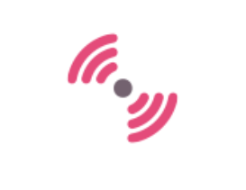

What to do ?

Develop a back-end application to send message to device via Azure IoT Hub

backend

application

Azure IoT Hub

device

Open Visual Studio / Create C# Console App .NET Core / Name = backC2D

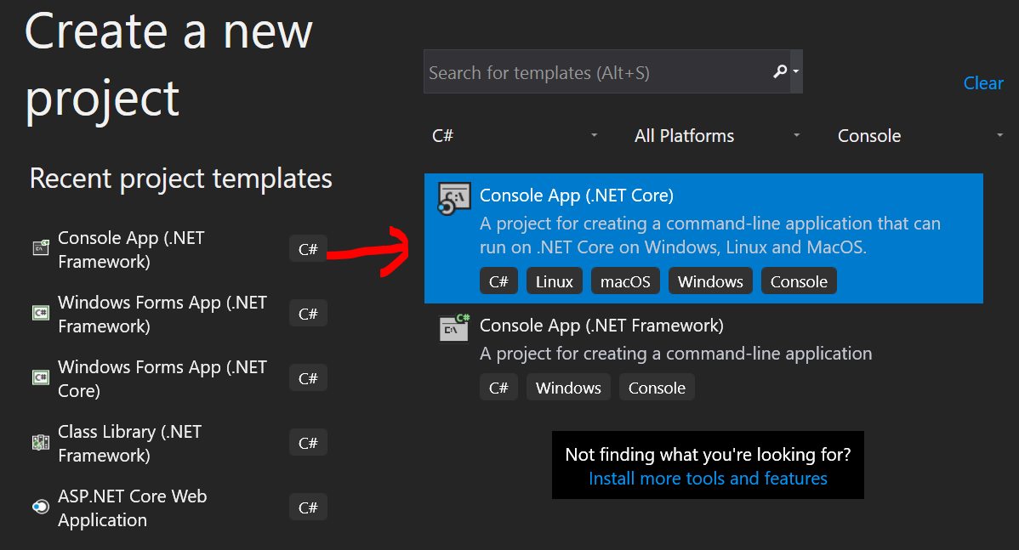

NuGet Microsoft.Azure.Devices

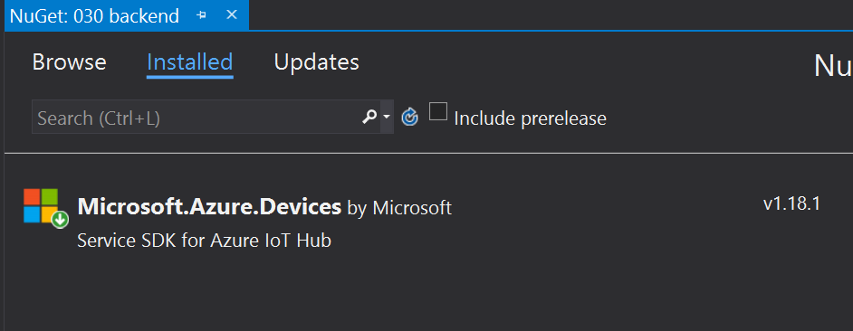

Add namespace

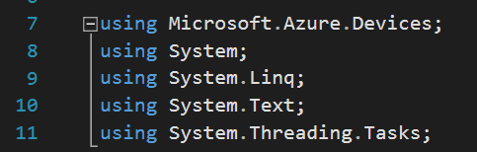

* Declare two class fields
* connectionString = Azure IoT connection string

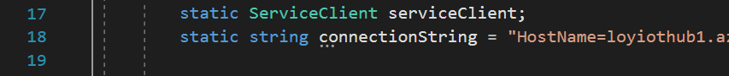

* Add method SendCloudToDeviceMessageAsync()
* Change device ID at line 25

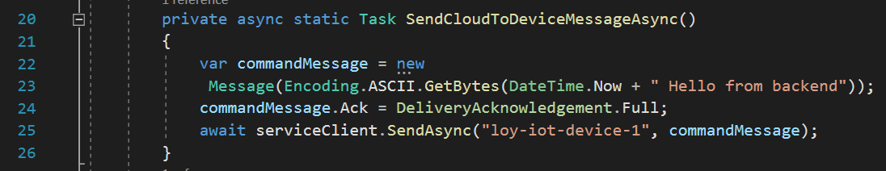

Add method ReceiveFeedbackAsync()

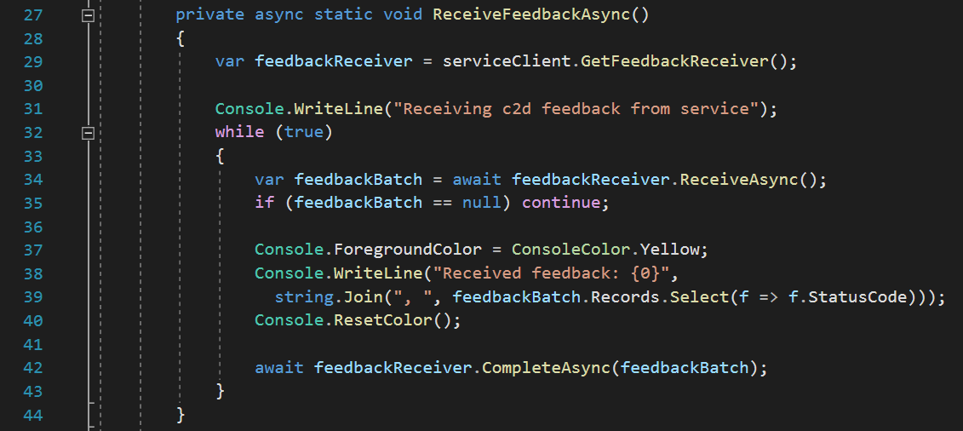

Add code to Main

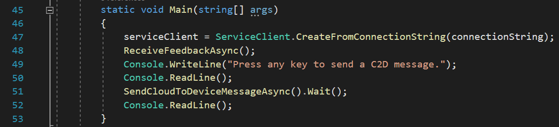

Run this program and run program C2D

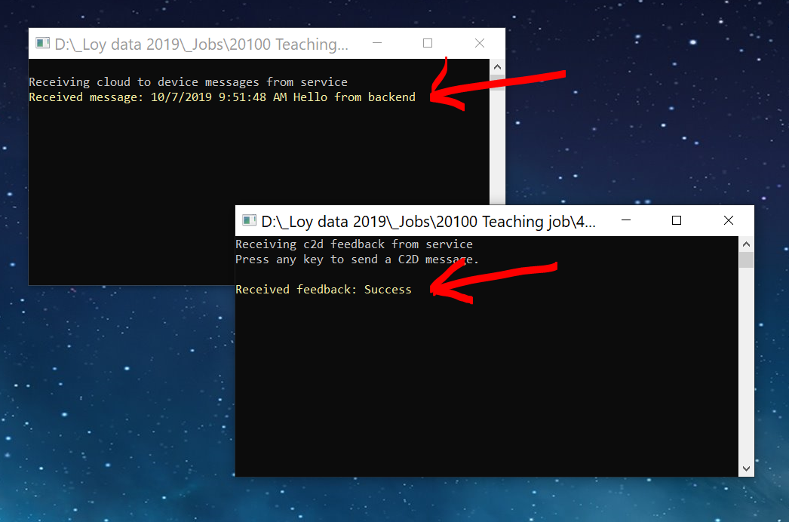

What's next?

